From A.I. to Comprehension, with an SST extended Knowledge Graph

Study case: using SSTorytime to learn language translation



Mark Burgess
Follow
18 min read
·
Jul 5, 2026
147
7
2
This case study about the SSTorytime project is an example of how we can blend the use of A.I. together with a knowledge graph built from independent human thought. I take a short story from Æsop’s Fables, written in Chinese, and try to translate it into English as a way of learning Chinese. Why? I’ll explain as we go. In the process, I hope to show how SSTorytime’s multiple mapping models are a tool that A.I. can not replace. This article follows on from Using N4L notes and SST Knowledge Graphs For Foreign Language Learning.
Translating one language into another remains the quintessential example of deep learning, bringing together all of the aspects of "knowing" into a collaborative whole. To master a foreign language, we need both expert knowledge of the language and we need to assess its specific use in contexts where it may be used ambiguously, metaphorically, or even humorously. We need to learn idioms and cultural references. Only a superficial version of this can be provided by direct transactional machine translation. When we engage a translator, we don't always intend to learn anything ourselves. That's their job.
One way to learn something is to try to explain and teach it to someone else (e.g. our later selves). This is why notes and storytelling are key to learning.
Computer translation has revolutionized language. Modern A.I. chatbots with their Large Language Models can do rather better than the simple phrase level translations of, say, Google Translate, but their expertise remains locked inside their expensive models–requiring significant trust in the A.I. and exposing us to the risk of either unintended or intended error. In the long run, human clients ultimately want to know and trust for themselves.
Relying on a large language model A.I. chatbot to gain enlightenment is a bit like asking for the answer to life, the universe and everything. The answer (being well known as 42) is unhelpful without knowing the question in a more pertinent form.
One can, of course, simply ask an LLM to translate a text for us. It will respond quickly with a professional looking translation, which will probably be quite good. Indeed, comparing Google’s Gemini translation with its own translation app, the LLM is vastly superior for its much better tracking of context. Even so, the smooth result from an LLM is close to useless if you are trying to learn the language. It tells you nothing about which words correspond to one another, or how the grammatical structure works. You simply have to place all your trust in the answer–making you vulnerable to attack in a critical moment.

Translating a story
Let’s examine a case study, using SSTorytime together with an LLM resource to translate a foreign language–in this case Chinese, in the form of a story from a storybook. It’s a simple source of material to learn from. A children’s story is suitable for a beginner. Although not everyone will relate obviously to this task, it’s a useful example because it has a certain level of complexity that goes beyond simple-minded relational thinking. I’ll try to keep the discussion general and for the purpose of pointing out the lessons.
Press enter or click to view image in full size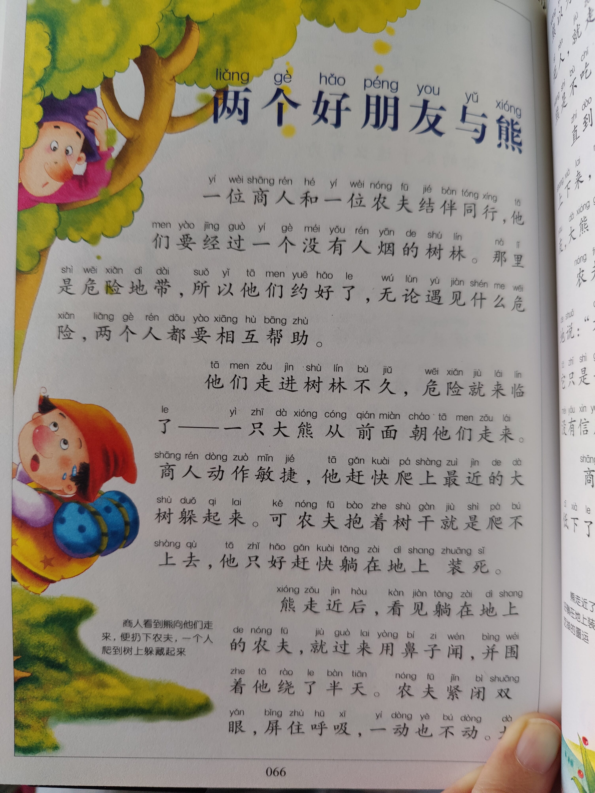
Press enter or click to view image in full size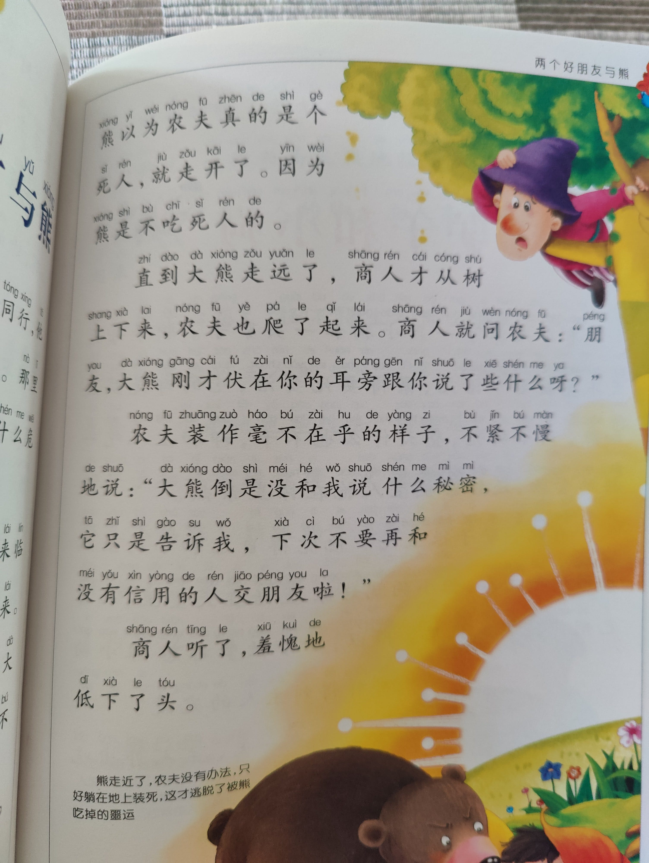
A book of Æsop's fables contains this story.
As a prelude to learning more Chinese, from a significant sample of text. we want to turn this story into N4L notes and add our comments and understanding as we learn. Some of those notes will vocabulary lists of Things and Concepts, others will be Events that form a storyline.
To jump to the conclusion, here is the "final" set of SSTorytime notes that I made from this example:

SSTorytime/examples/chinese_story_bear.n4l at main · markburgess/SSTorytime

Semantic Spacetime Story graph database library over postgresql (SSTorytime) …
github.com

Of course, notes are never really final. The point is to improve them over and over again. The rendered, compiled notes can be viewed in SSTorytime in a number of ways.
Press enter or click to view image in full size
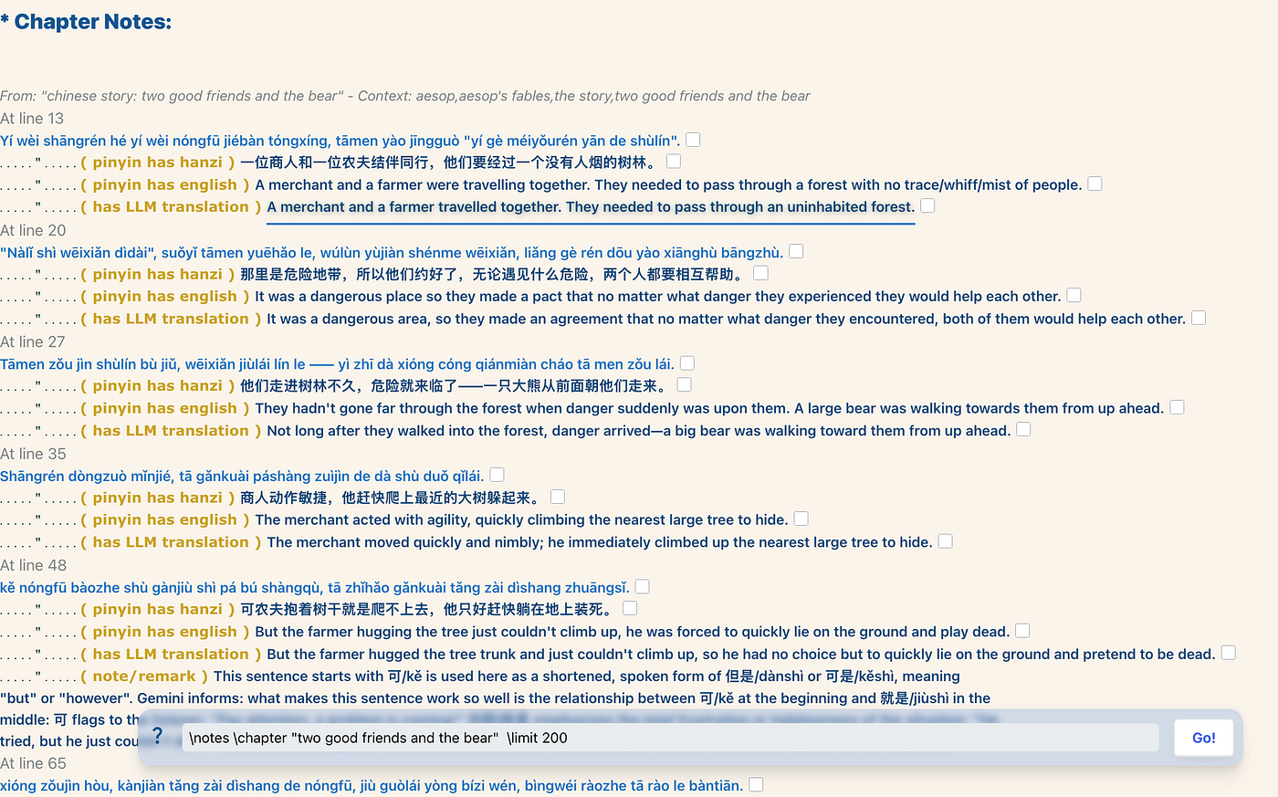
Notes view of the N4L, basically verbatim — as intended.
In the discussion below, I’ll explain how it arrived as this.

Mapping and tracing knowledge
A basic semantic knowledge graph is an insufficient structure to represent knowledge in a useful way. As always, you can pour information into a data store, but it's useless if you can't get it back out again. Direct linkage between nodes can cover many of the search requirements for knowable material, but we also need meta-constructs like "sections", "themes", and even simple bookmarks to give names to complex patterns. This is not a question of "ontology" in the sense of the semantic web. It's about slicing and dicing data in appropriate chunks.
Let's see how to apply the SSTorytime tools to language.
Knowledge comes from the investment of work that builds trust. Each of us ultimately has to take responsibility for our own knowledge. Learning a language isn't easy, by any standard. Hearsay isn’t knowledge — even if it comes from a professional translator. What you can cut and paste, only becomes knowledge if you actually know the material yourself–"like a friend". That takes experience and practice. SSTorytime was developed for capturing such experience. as a different kind of knowledge representation tool — specifically for this kind of learning.
Our case study, here, is based on a goal of my own: to learn some Mandarin Chinese. Having learned (and forgotten) several languages in the past, I have some idea of how the process works–but Chinese is challenging in a new way for me, because it has non-alphabetic writing and tonal inflections that are unfamiliar to me. Some people can hear language and parrot it, but I am a visual thinker, and I need to see words in my mind to understand and remember them. My random access memory is very poor. My career as a database was always a non-starter.
Only by critically examining a case that I care about myself do I expect to learn what is involved in language. I know my abilities quite well, so I have some idea of what I need to do.
Traditionally, languages were translated laboriously with the help of directories or dictionaries of words, with annotations about usage — and by consulting the advice of bi-lingual experts with experience. This approach has a number of weaknesses — apart from being arduous. The multi-valued nature of words means that a single word or phrase might mean any number of things in different contexts. This is particularly true in Chinese, where the symbolic nature of the writing has evolved with the spoken language(s) so that each syllable corresponds to a character, but characters are generally paired together to emphasize particular meanings and to disambiguate ideas. As a foreigner coming to Chinese, knowing how the language works is essential, because a small number of similar sounds gets reused many times, with different inflections and contexts, to form different written characters. The writing plays an important role even in speech. The logic of this is clear to an expert, but the unwitting student can easily get lost.

Training your brain model
So how do we learn? Training a mind is not like training a machine model. We need source material, fed to us or discovered by us somehow and we need to trick ourselves into assimilating it.
No one can program us to learn, just as no one can make us into an athlete by uploading strength and endurance from a gym. Those are qualities we need to find in ourselves, through repeated exercise. And we only learn to know things and people we care about. Caring is a resource saving tariff–explained by the Dunbar numbers. It gives us priorities. How, then, to go about it?
We start with simple words: numbers, please, thank-you, etc. After writing down some phrases and some basic words, it's easy to lose interest. Collecting individual items is dull and tedious. It's building a key-value store whose usefulness is not obvious. One needs to sustain interest and motivation by looking at longer texts: movies, books, stories, because these offer emotional stimulus and relevance.
As a lifelong learner, but a failed database, I know that I need to write notes to help me. That might sound simple enough, but there are good notes and bad notes. Learning is not about logic or facts. It's about tricking oneself into memorizing. Sometimes I need to do:
- Rote learning — cramming words by repeating mindlessly.
- Analysis and comprehension — deep studying of relationships, by understanding words and structure.
- Straightforward natural translation — learning colloquial idiomatic phrases
- Sensemaking translation — looking for the “aha!” in a sentence.
Using a computer to help with learning is, of course, an intriguing challenge in itself, but I’m mindful of the statistics here in Norway that show how kids’ literacy skills have dropped by 40% since computers were introduced into the classrooms to replace books. That’s a major red flag for any learner. Meanwhile, apps have been popping up with educational claims. The interactive engagement with a computer program is potentially valuable in managing boredom and motivating. Duolingo was originally a nice way to learn, but after a good start the company embraced the Silicon Valley trope of gamification and turned the platform from a learning platform to a gaming platform for kids, making it intolerable. More time is now spent getting past flashy and unwanted game constructs than is spent actually learning.
So, I have looked for a replacement. Centuries of teaching experience is not for nought. We simply go back to noting down:
- The names of things.
- Basic action phrases in practical contexts.
- Some idioms for please and thank-you etc.
- What questions would I need to ask, or to answer in a crisis?
- etc
These are strategies. To learn, we also need to engage motor skills, because motor skills are tied to our “intentionality”. If we don’t truly intend something, we will probably not actually succeed at it. Unlike machine learning, our human memory is not a logical or reliable key-value store, it is tied to associations and emotional context.

Designing views
We need different kinds of data representation for different purposes:
- Random access lookup.
- Contextual disambiguation.
- Continuity in a storyline.
If your view of knowledge management is to create a museum map of artifacts, e.g. corporate assets, procedures, and data records, then you are still basically making a telephone directory of items and their addresses. No one wants to memorize a phone book. But is this really what we mean by knowledge?
What if, instead, the database was a collection of stories and experiences for its staff, its history, and its mission? How would we want to browse that information? The issue here is that, while there are certain bits of information that are immutable and consistent and therefore form a single “entity”, we want to present that information as part of a process. Humans do not want to see a complete 3rd Normal Form data record when interacting with knowables. To a software developer, it might just be data, but to a learner it’s a character in a story of their own making.
This is what SSTorytime does. It keeps two main models: a graph (from which several views can be built), and a page view, which creates a page layout organized according to the intent of the note-taker.
In IT, commercial competition promoted the idea that one database could solve everyone’s problems. There was only one answer, and it wasn’t the one you were using! Today, we have arrived at multi-model databases with more open minded possibilities. Software engineering has not yet caught up with this open-mindedness however. The alternatives?
- Key-value stores (with schemas)
- Graph databases.
- RDF/OWL
Each of these uses machine logic to some degree. In The Failure of Knowledge Management, I wrote about why logic is a misunderstood goal. Again, software engineers have seized upon it as a panacea, when in fact it is only a weak approximation.
RDF was designed for globalizing data, as if one could share in the writing of a global Encyclopædia Bureaucratica through a kind of bureaucratic wrapping: applying for a unique identifiers through the internet agencies. There are many reasons why this model is unlikely to succeed. The age of the eternal organization has long since passed, so domain names do not last as long as we might hope. Knowledge is local and individually meaningful. Deal with that!
Twenty years ago, in 2006, I was intrigued by the idea of a knowledge graph. The reasons for abandoning it have to do with its lack reliance on logic through OWL. It was quickly possible to show how it was greatly overconstrained, so that in the end the free-thinking graph was just another key-value schema with a lot of extra mumbo-jumbo attached. SSTorytime is my best answer to representing what knowledge is for.

Asking an A.I. assistant
Let us simply acknowledge that Large Language Model (LLM) assistants are amazing for any number of reasons. I have serious questions about what people are using them for, and about the desperate push for brain capture imposed upon ordinary folks by our tech overlords, but that doesn’t take away the accomplishment they represent. The assistants are not to be trusted with every task, but they are superb at carrying out tedious transformative tasks like transcribing and answering questions based on general contexts.
We can take a picture from the book and ask the A.I. to extract the text in pinyin, hanzi, and english. The basic output of the translation is a stream of chinese characters, pinyin syllables separated by spaces, and finished English, without any explanation. Each line becomes something like this:
Press enter or click to view image in full size
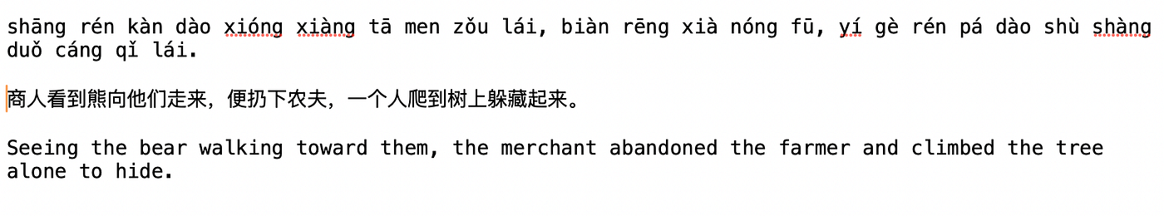
The raw output of the A.I. assistant is not useful without editing and making notes about it.
If we only want to know the meaning in English, this is enough. However, this is not very helpful if we are trying to learn the language. We have to ask what no A.I. will ask: what can we learn from this?
We start to turn this into N4L notes, by adding some context, forming a story sequence, and adding arrows to the different parts and words. Note that this requires us to collect those words that are formed from two syllables into a single pinyin word.
Making notes on these is easy enough, using N4L. For example see the figures below. Here, my SST graph arrows “(ph)”, “(eh)”, etc, map between the three language forms I need: “pinyin” (romanized phonetic transcription), “hanzi” (Chinese characters), and English. There is a subtlety here: I always start with actual Chinese to minimize the risk of mis-translating. Sometimes, you want to know how to say “X” in a foreign language. Then there are two options: a sort of direct translation for what you want, and then “what people actually say”. The difference here may or may not be appropriate for a novice.
Press enter or click to view image in full size
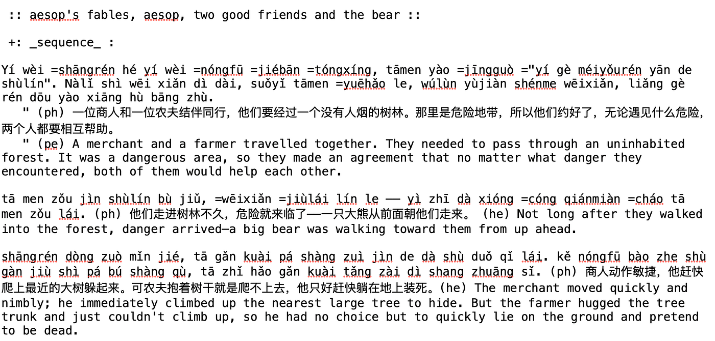
The stages of annotating the text. The first line is fully annotated, the second line has added the arrows between english, pinyin and Chinese, while the last line is the raw translation in 3 forms from the chatbot. By placing an = sign in front of a word, we create a link annotation to that word, to be explained furtehr below.
Next, we start to look at the individual words to form a vocabulary, and extract them as individual components (containend by their sentences). Which words do we need or want to know?
Press enter or click to view image in full size
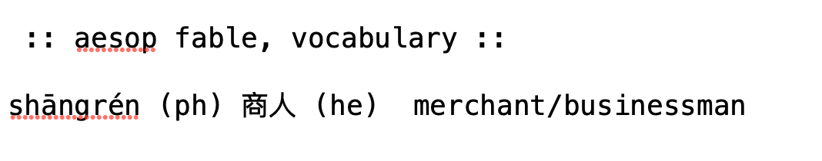
Annotating the links created by = references
Extracting words is tedious and cutting and pasting them from one place to another can also lead to confusion context switching. Here we can use the N4L language to cut out the words and leave them underneath the sentence where they were found to be collected together later and turned into notes. This is much less confusing that transcribing one by one.
Press enter or click to view image in full size
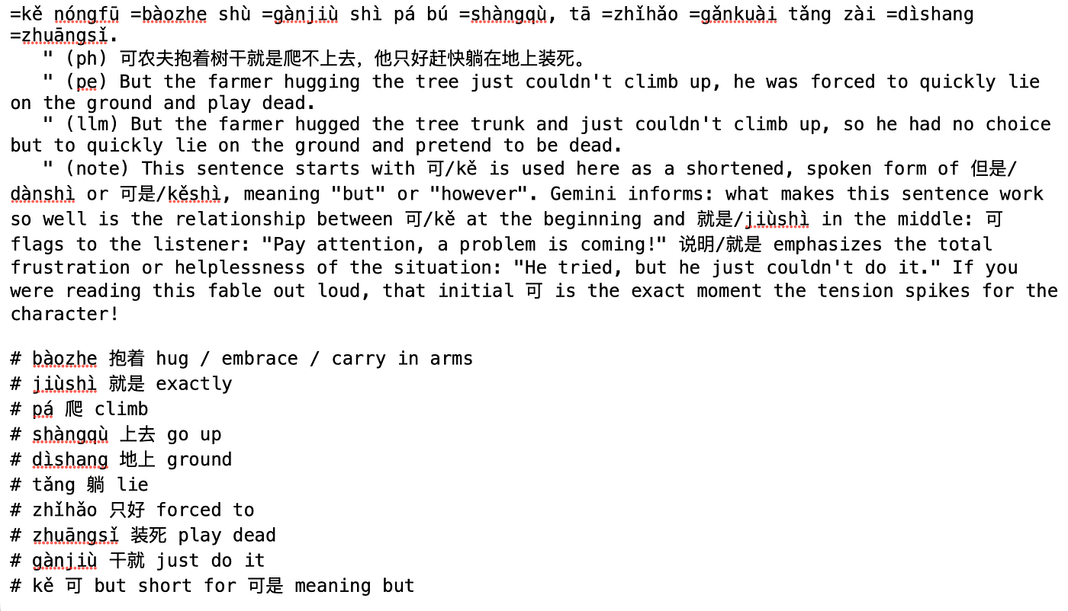
Using coments in line permits some systematic analysis to be formatted later.
By linking these to sentences that contain them, we have bidirectional pointers between examples and abstracted parts.
One trick that I learned when keeping a translation is to keep two versions: the smooth version from the LLM, and my own breakdown of the meaning, based on my own understanding of the words. This is important, because my own version makes more sense to me, and so I am likely to remember it better. Often these two merge together as one learns more.
Notice that SSTorytime's N4L note language makes this much easier than it would be in any other graph representation. We just need to mark up the text with a symbol like "=" and attach it to an arrow. The compiler does the rest.
In an alphabetic language, a dictionary might suffice for much of this analysis, but in Chinese there are no spaces to show us where the word boundaries belong. Characters may be grouped depending on the context to form significant pairs. Having a expert to ask is a major boon. For phrases and words in the text, we can ask the assistant to explain:
Press enter or click to view image in full size
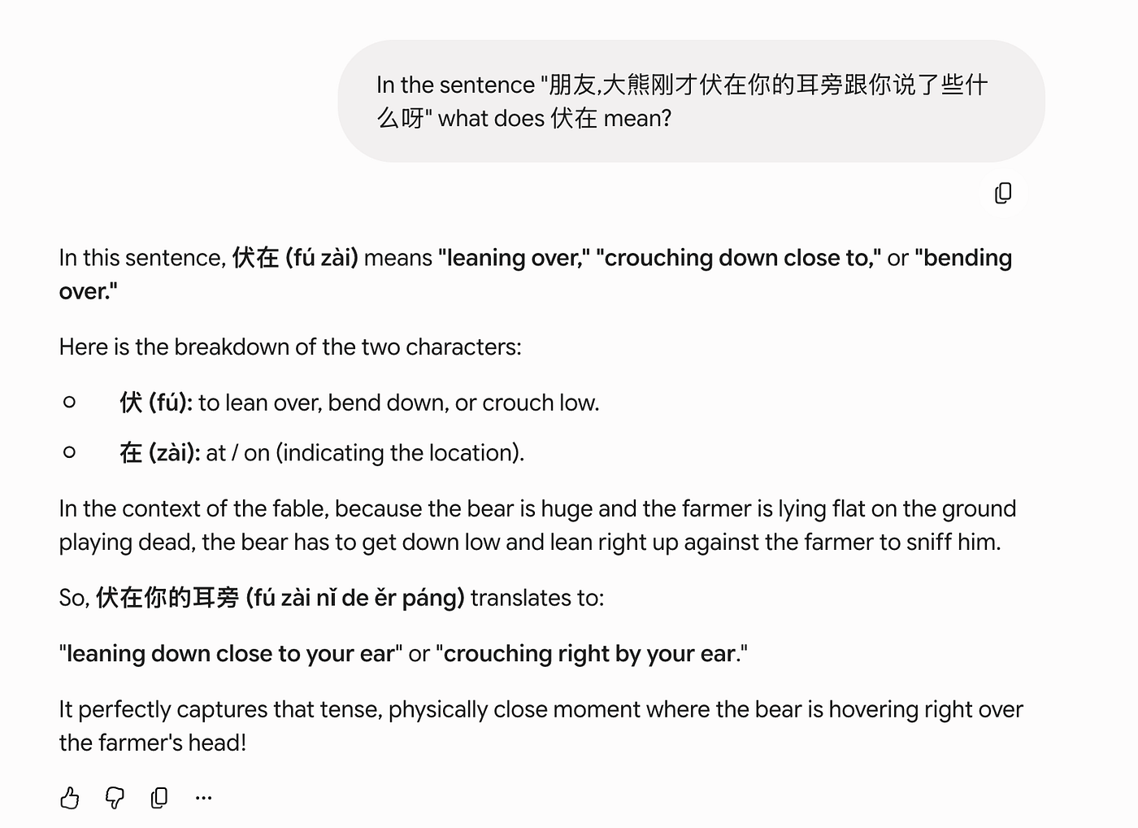
The A.I. assistants are quite good at this and rarely make a mistake — while translation apps will often just pick the first most probable meaning and get it wrong.
Once we have a set of notes, we can compile them into SSTorytime using the N4L compiler. When we now click on a sentence in the compiled form, we get the orbits of the sentence in graph form:
Press enter or click to view image in full size
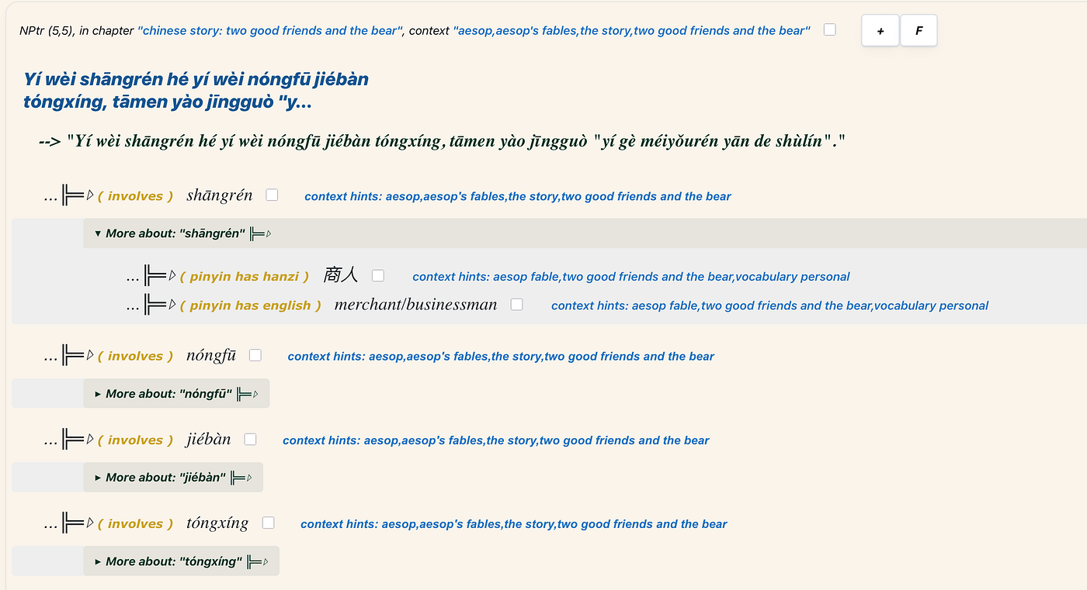
The graph orbit of the sentence in SSTorytime, linked up through the N4L notes
We have translations here, but there are other ways we want to consult our notes! For instance: show me just the vocabulary list associated with the story. If we want to learn the vocabulary list, then we don't want to have to search and click our way around the nodes of this graph. We want to see the specific list of words in the order we wrote in our notes, collected in one place and ordered, with our own commentary. For this, we use the \\notes view.
Press enter or click to view image in full size
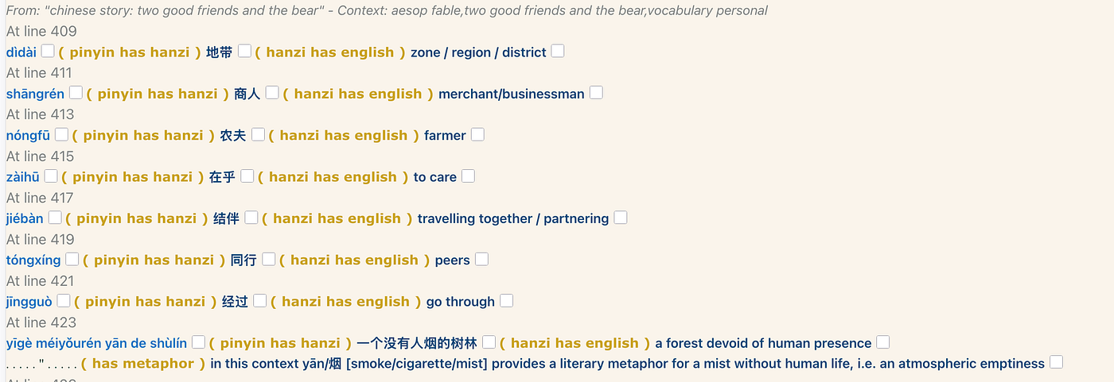
The vocabulary list can be seen in \\notes format
No matter how many times we repeat a word, SSTorytime only stores these items once, and cross references them as a knowledge graph — so it can also retain the preferred view of human notes from a page in our notebook. This is usually a lot more useful to a human learner than a graph.
As I’ve written previously, in Curating Your Own Thinking Experience, with Semantic Notes?, natural language has significant advantages over “knowledge graphs” for semantic representation. That is simply because the way we use knowledge graphs is to impose a logical model onto them, which is too primitive to capture the kinds of concepts that humans work with in daily life.
Simplification is good, but oversimplification is a liability.
So, why wouldn’t you simply ask an A.I. to translate a story and be satisfied? The simple answer is that one learns nothing from doing this. The major problem with A.I. language models is that they present answers as a fait d'accomplit. We get an answer without understanding the reasons.
Promise Theory’s Downstream Principle makes it our responsibility to assess and integrate new information individually. For a person to learn and understand something, we need to dig into the subject with intentional questions. This process doesn’t accept data like a key-value store, but creates a web of ties to other emotionally resonant memories.
We can try to manually create a knowledge graph about an experience to learn from. The problem then is the sheer amount of work needed to find out the intended meaning of the text from various sources. The process, by which A.I./LLMs are trained, is massively tedious and it draws on sources far more diverse than any individual could in a reasonable amount of time. Moreover, we can ask specific questions about usage, based on its clever model–the same questions that we would ask another person with an expert and tireless knowledge. The difference is that we have access to the A.I., but we don’t always have access to a person.

Motivation
You can only go so far collecting information with notes. You won’t learn much or even understand much unless you use what you've noted down. Action is more powerful and wishing. This, of course, is why transcribing with a pen is more effective than cutting and pasting from the Internet — or even typing.
Personally, the barrier I typically face is: caring enough to truly want to learn in the face of many distractions (like having to write an article)! Deep motivation to learn is an elusive unicorn when surrounded by trivia. No amount of discipline will face off an endless inability to concentrate. To win concentration, we need an emotional connection (and a points-winning game offers the wrong incentives).
In another article I wrote: Describe the Scene! The Investment in Context, I explained how one deconstructs a scene to find meaning. There’s a kind of search algorithm that we execute unconsciously. Crime Scene Investigators (CSIs) train to be good at this. You start with gathering ambient data: the context. You identify the things, i.e. the dramatis personae in the play. You look for key events. You look for details that might help to disambiguate things. Finally, you look for intent. It’s a descent from passive (ambient) information to active (intentional) information. The aim is to construct a story from those pieces.
Stories are one kind of source that can grab our attention, because stories do two things:
- They engage curiosity with a continuity of context and attention, with emotional engagement (kinetic trust).
- They associate ideas across multiple scales (deep context).
Of course, both of these are dependent on being able to trust the sensory experiences or inputs we receive. So there is verification needed to be certain that what we are “promised” is in fact true (potential trust). Balancing the use of AI for targetted tasks, rather than for the whole task, is a way to keep control of trust.
For me then, I look for simple stories that will feed me a steady vocabulary in a consistent and meaningful way, with words and phrases that I will encounter in a real scenario–but crucially, in a way that feeds my curiosity, my desire to know.
When I learned Norwegian, I chanced upon a set of Desmond Bagley's thrillers that fulfilled that purpose very well. Initially, it was very hard work to read the novels. Every word was new, and every phrase seemed foreign, but Norwegian is an easy language. Eventually, I got into a balance of understanding just enough to be able to read the books fluently and to be able to think in Norwegian. Speaking was a separate challenge, of course. Chinese is much harder for me than Norwegian, for reasons already mentioned.

Searching and studying
We make notes so we can read them and study them.
SSTorytime attempts to encourage a loose discipline: first simplifying the structure of the graph, by largely eliminating ontological types, and then by rather encouraging us placing knowables into one or more suitable context boxes. In other words, it relaxes the rather punitive burden of requiring formal types, which attempt to impose expert programming logic onto the curious user.
SSTorytime avoids a formal search language, in favour of a few simple directives. A query language like RDF's SPARQL is a schematic type matching language, designed for strict type-based pattern matching. This is not how humans think, no matter what software engineers might pretend — even disregarding RDF's clumsy XML encoding. Fuzzy matching has been understood since the earliest days of search engines.
The problem with schema based model searches, like SPARQL and OWL is that a user basically has to have a detailed and expert knowledge of that schema and what is in a database in order to be able to search it. This feels counter productive, but actually it's worse than that. It makes searching extremely fragile to errors, and virtually guarantees that you will never learn anything you didn’t already know. In that (limited) sense it is true to the idea of knowledge representation–but it can never be a tool of discovery or learning.

Bookmarking cross sections
One way to know a translated text, like a friend, is to make meta-notes about the process of learning. We are good at giving phenomena nick names. This is what SSTorytime is for: by making notes, we create a searchable map with several inequivalent representations that we use for different purposes. We can now bookmark specific search criteria by giving a complex search a simple name.
From the notes, click on the BM button, or type \\bookmarks.
Press enter or click to view image in full size
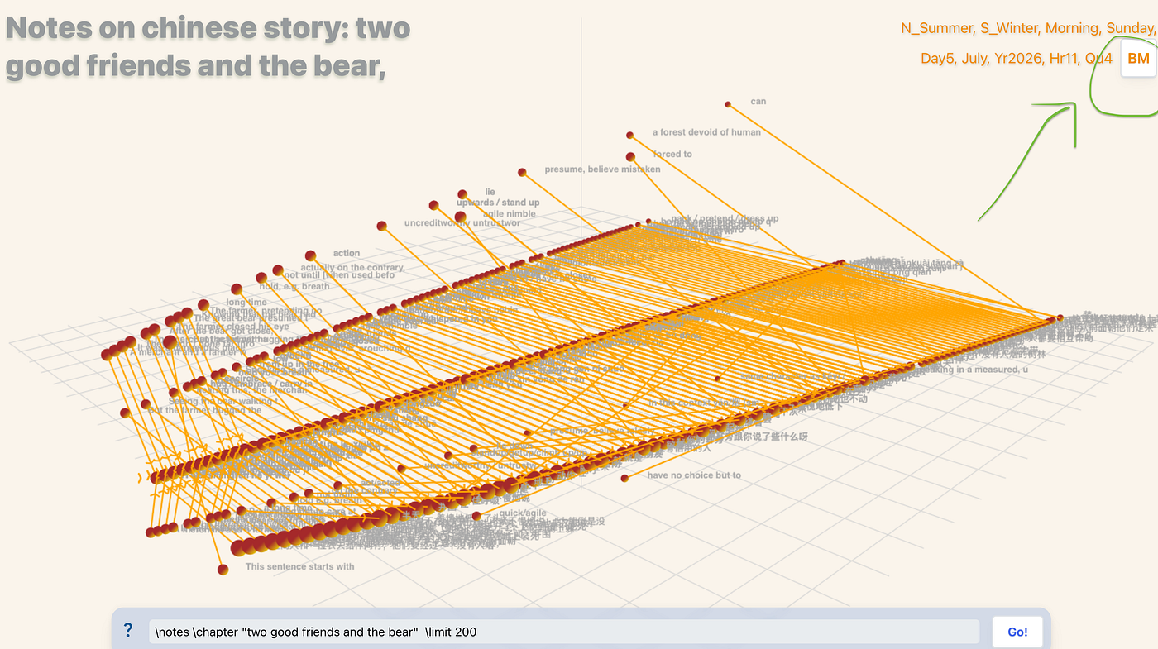
Hit the bookmarks button to jump to a set of saved searches, extracting cross sections from all over the knowledge graph. We can use this to curate different experiences from the same data.
We now arrive at a page with a small number of topic sections and specific sub-stopics represented by context searches, just from a click.
Press enter or click to view image in full size
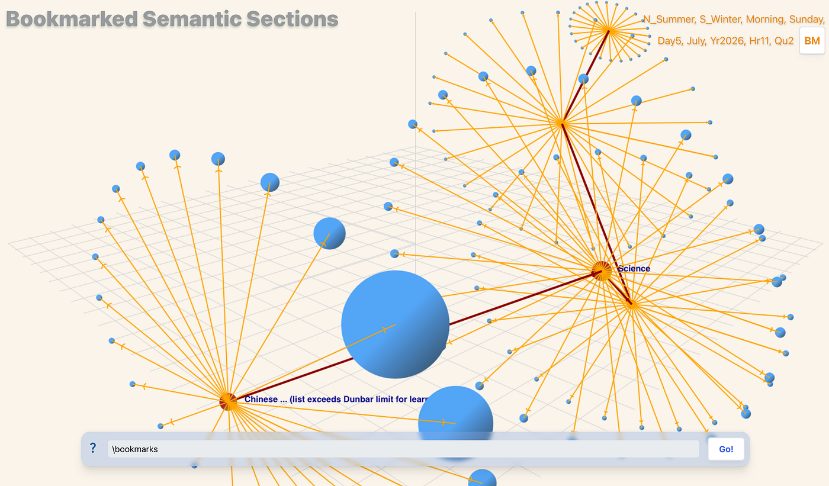
SSTorytime will even warn you when the number of sub-topics starts to become counterproductive in terms of our Dunbar limits.
Press enter or click to view image in full size
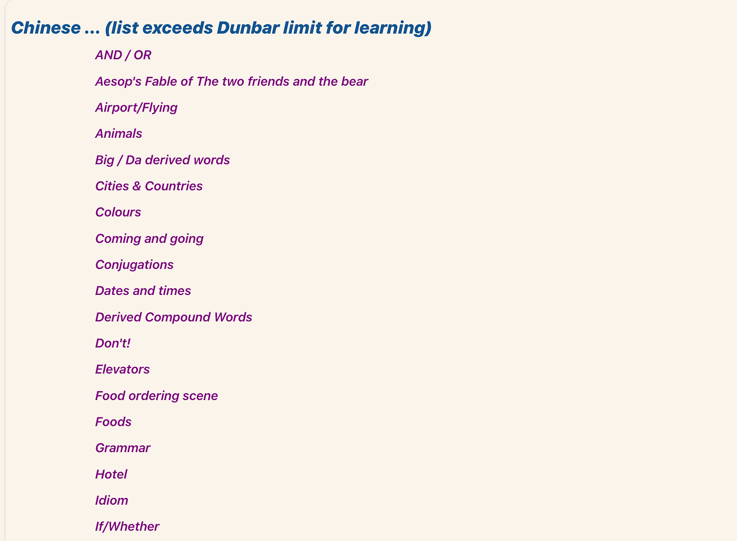
Different saved searches, collating notes from all over the graph.
Effective knowledge representation goes beyond what can be captured by a single relational graph. Semantic spacetime can represent the pieces of a puzzle, but how does one slice and dice the graph in order to make sense of something?
Humans do not store information in 3rd normal form–and my personal peeve is that software engineers are still trying to apply a method that was designed for consistent data entry in the age where humans had to feed in data manually. The key to knowledge lies instories–which is where language wins.

Postscript
The first lesson, which I’ve explained on many occasions, is that a useful knowledge map is not logical. Our knowledge graph is, effectively, ontology free.
In the end, the challenge of learning is more important than the facts. It's about the process — with SSTorytime we have tools to support that process. It works best when we gradually adapt the material to our needs. This is what it is to be human. We rely on caring rather than the logical rigour behind RDF/OWL and even schematized databases. For a few tasks, the emotional element can be abstracted and captured to some extent with the help of A.I. assistants— to abstract universal emotional elements that give meaning to text–at least to some extent.
And, as far as language is concerned: if you ever try to translate a foreign language yourself, it is a truly difficult and sometimes surprising task until it isn't. After centuries of international relations, even the most disparate languages have borrowed from one another. There is surely a lesson here about how knowledge works.

